CASE STUDY 28 Repeated Transaction Detection
1. Problem Statement
Examine a list of transaction identifiers and amounts, flag repeated identifiers and amounts above a supplied threshold, and list suspicious transactions.
2. Objectives
Store transaction records in tuples and lists.
Use loops and conditions to identify duplicate identifiers.
Generate a simple audit report.
3. Assumptions
Each record contains an ID and a non-negative amount.
An ID is expected to be unique.
Amounts strictly greater than the threshold are flagged.
4. Algorithm
1. Read transaction count and threshold.
2. Read each transaction ID and amount.
3. Reject empty IDs or negative amounts.
4. Compare each transaction ID with earlier IDs to detect duplicates.
5. Flag amounts above the threshold.
6. Print each transaction with its findings.
5. Flowchart
6. Pseudocode
START
INPUT n, threshold
READ valid transaction tuples (id, amount)
FOR each transaction i: flags = empty list
IF id occurs earlier: add duplicate flag
IF amount > threshold: add high-amount flag
PRINT flagged transactions
END
7. Test Cases
Test | Input / Scenario | Expected result
1 | T01 ₹500, T02 ₹1500, T01 ₹200; threshold ₹1000 | T02 flagged high amount; second T01 flagged duplicate ID
2 | A ₹100; threshold ₹100 | No flag because threshold is strict
3 | amount -5 | Invalid transaction
8. Output Screenshot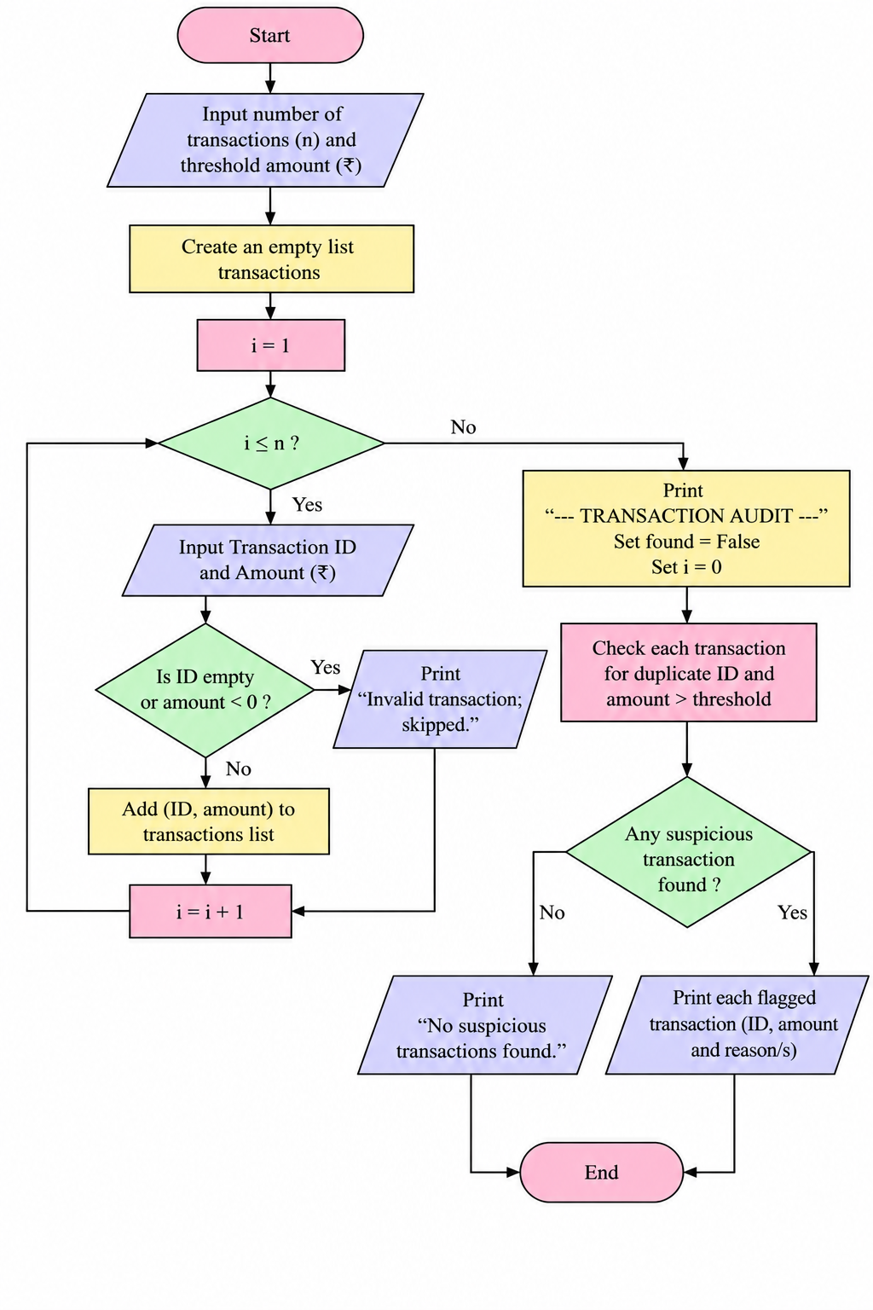

9. Conclusion
The program performs a basic transaction audit using tuple records and identifies duplicate IDs and high-value transactions.

